NAME: SAJITHRA.K

TASK: 1-GITHUB

1.GITHUB SIGN IN:

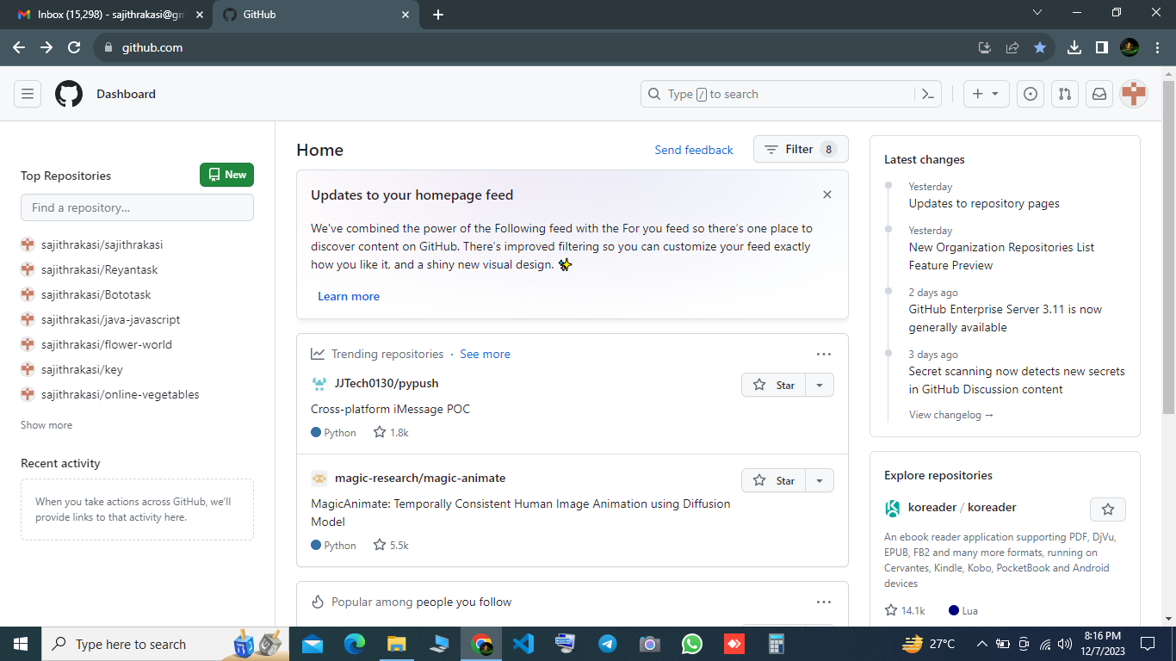

2.CREATING A NEW REPOSITORY:

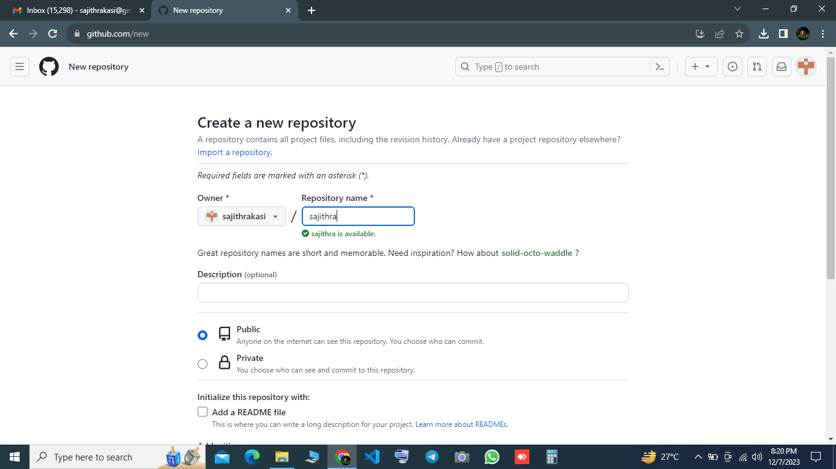

3.CREATING REPOSITORY NEW FILENAME:

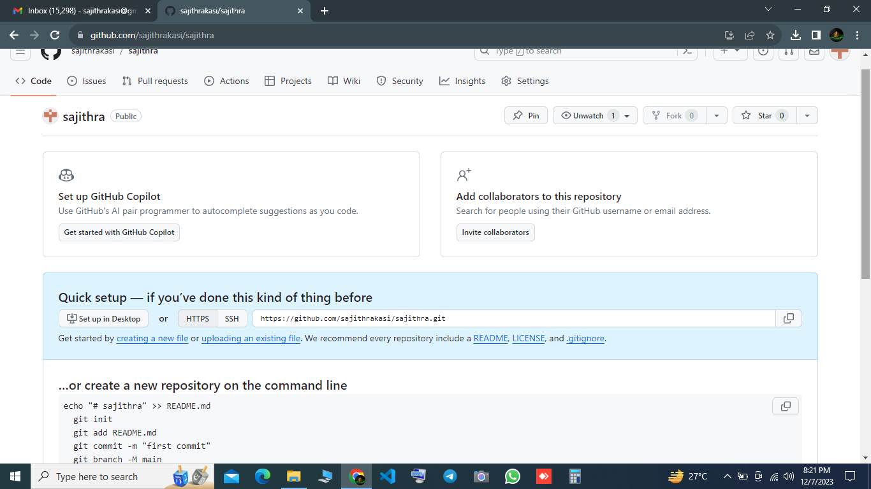

4.STORING CONTENT ON FILE:

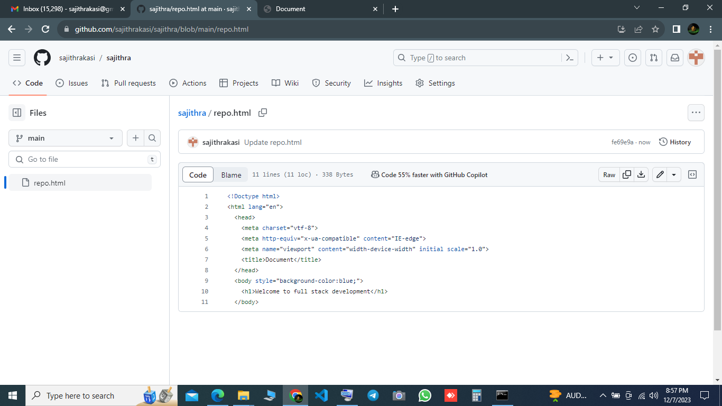

5.CREATE FOLDER IN WINDOWS:

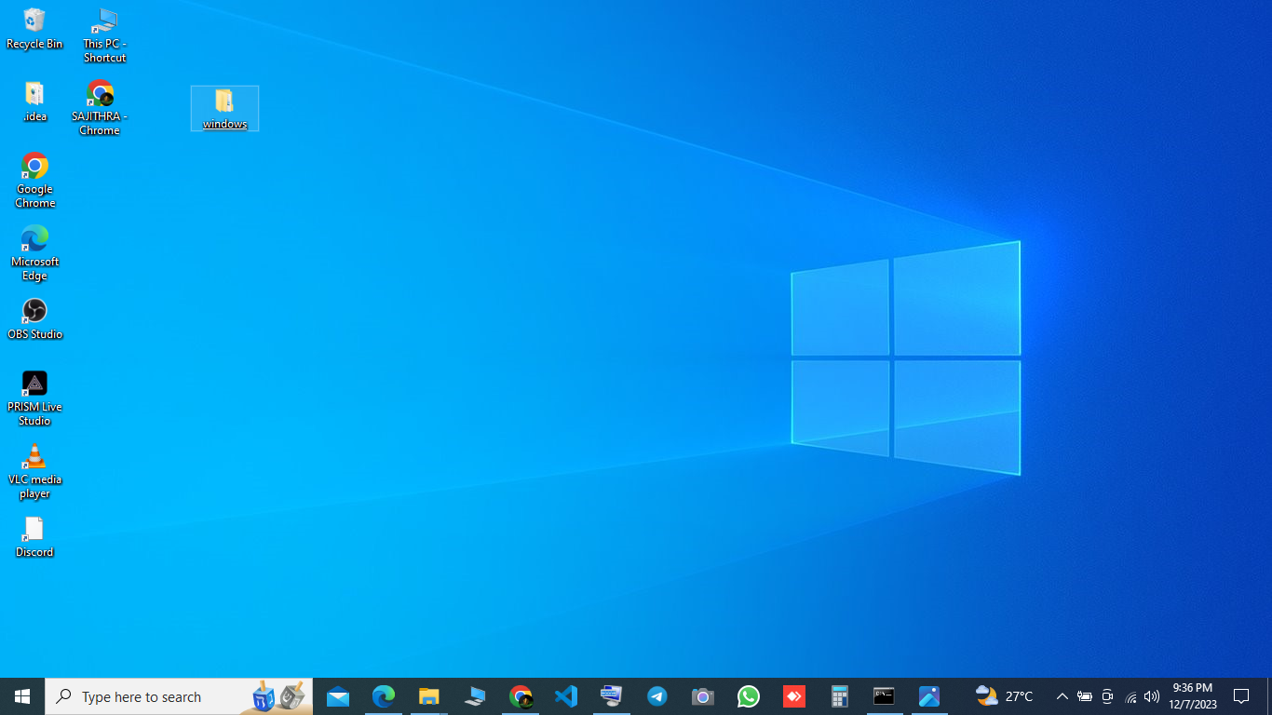

6.OPEN COMMAND PROMPT TO CALL DESKTOP AND CREATED FOLDER:

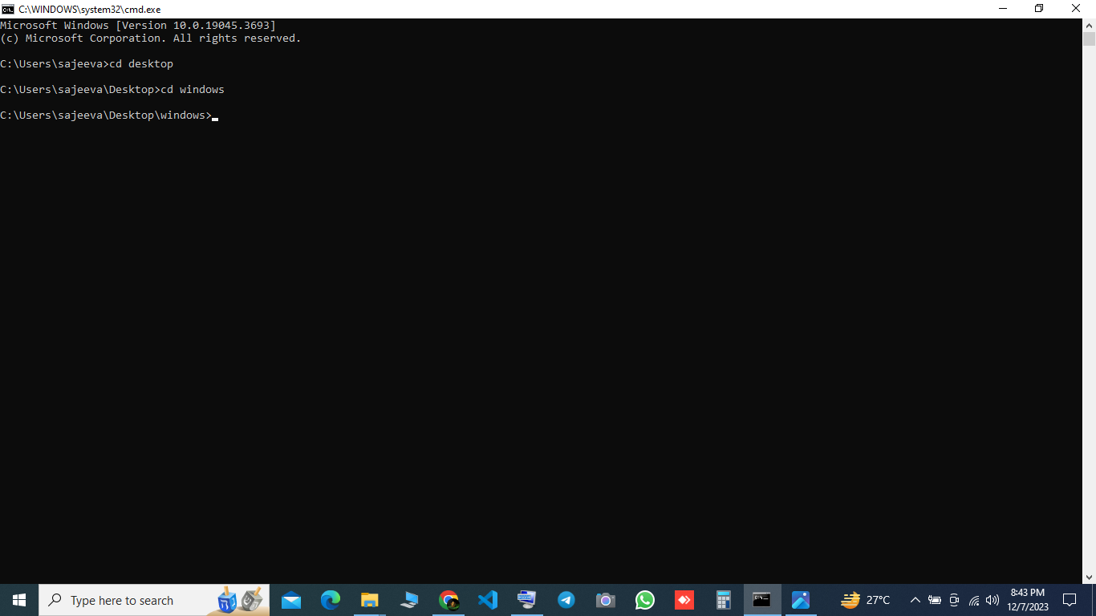

7.CLONE THE REPOSITORY FILE WITH LINK AND WINDOWS FOLDER:

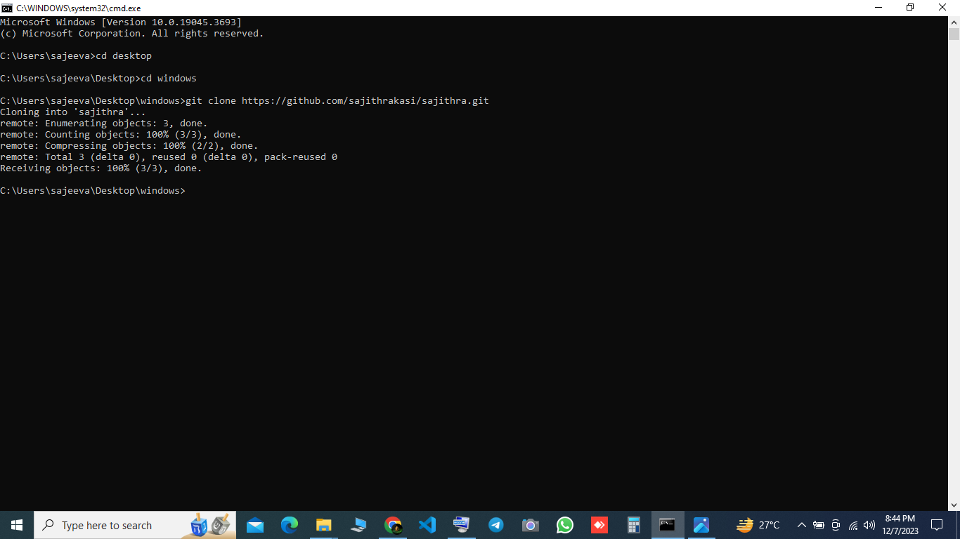

8.CLONE OUTPUT:

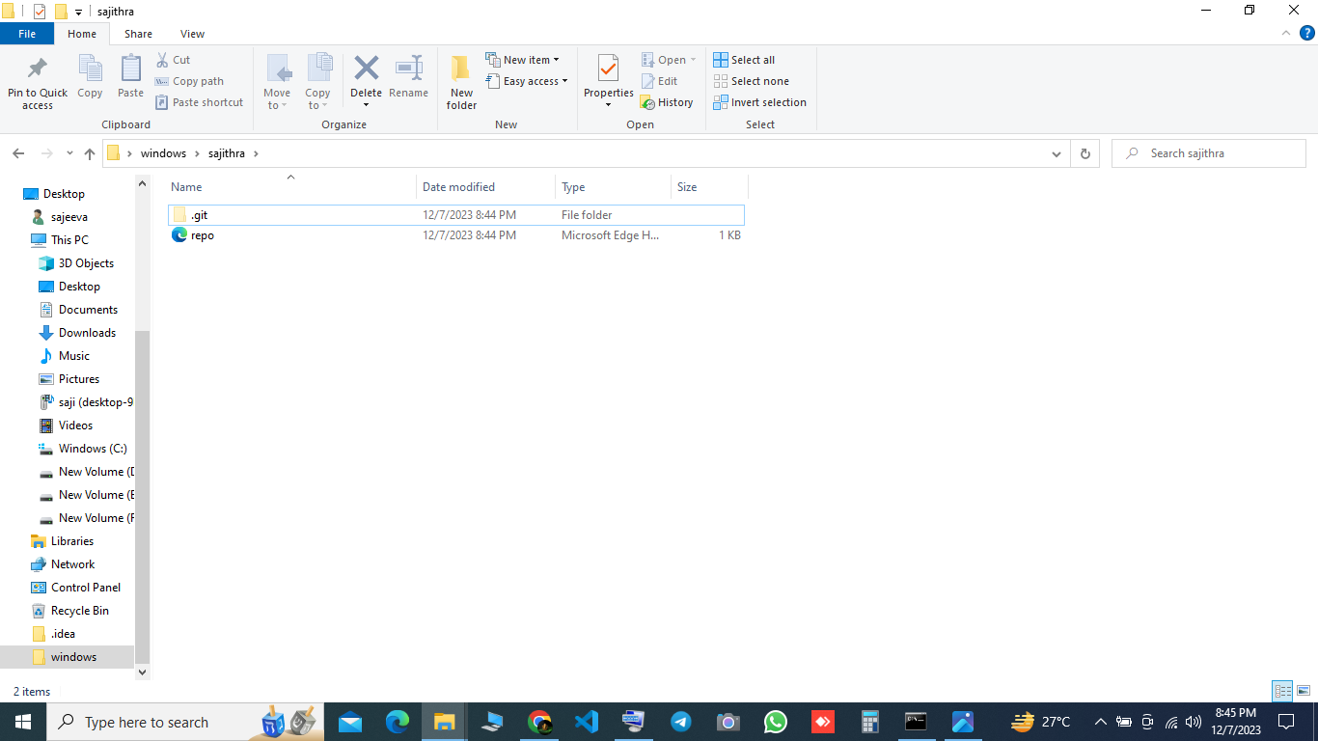

9.CREATE TEXT DOCUMENT FILE:

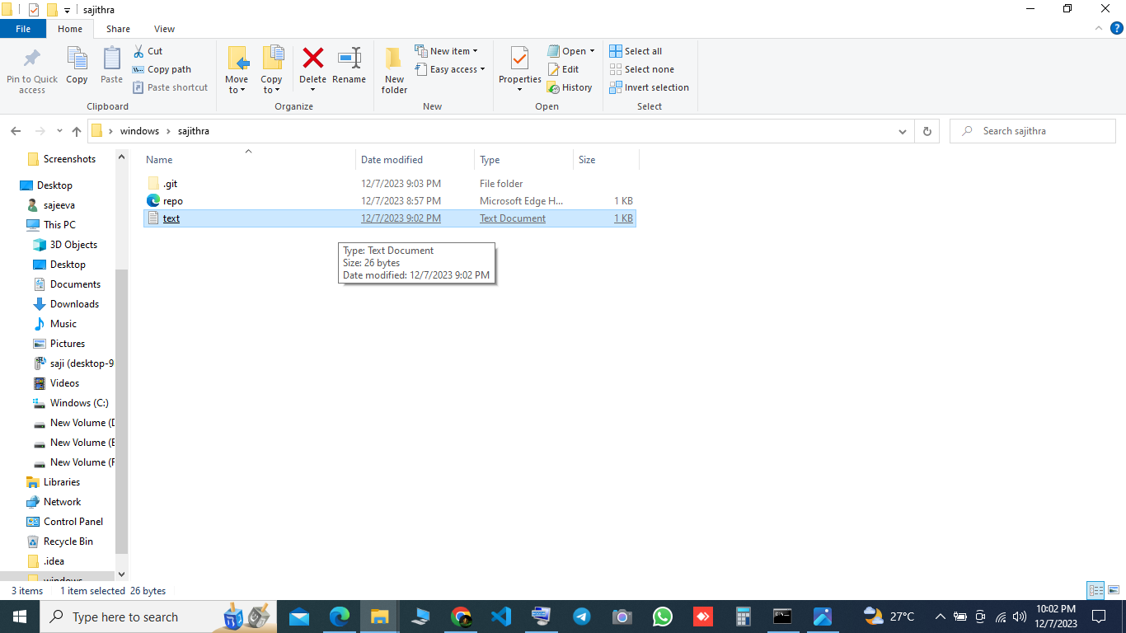

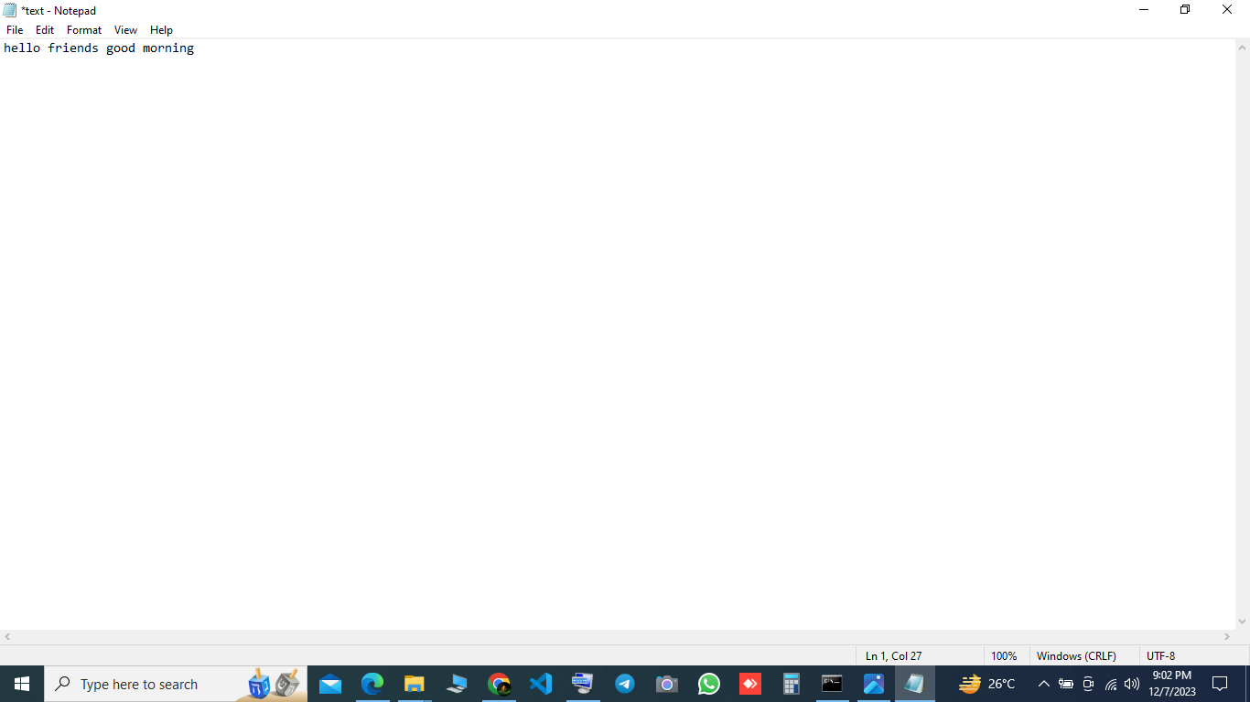

10.ADD,COMMIT,PUSH:

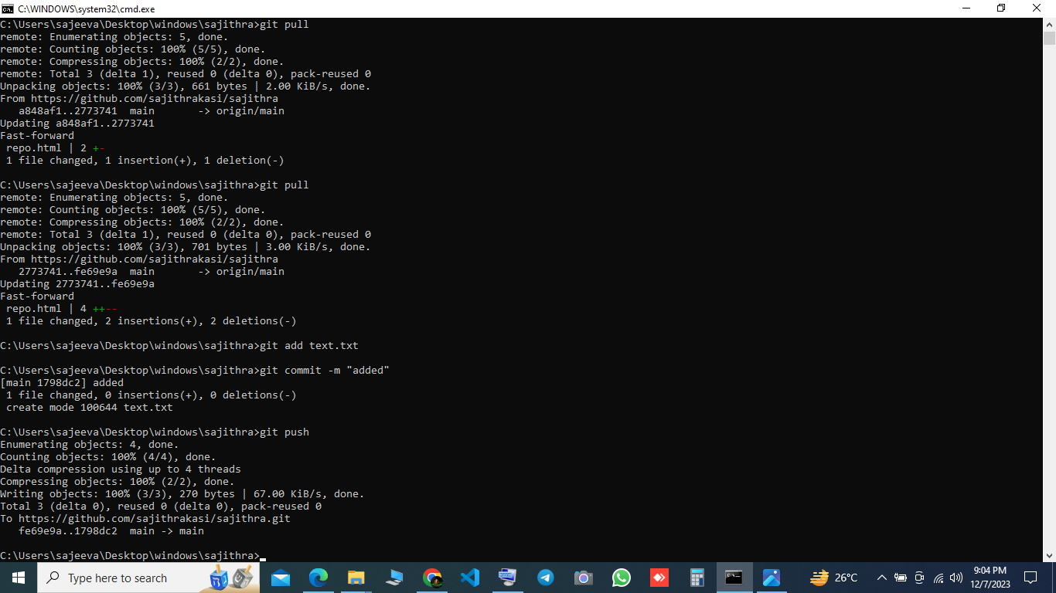

10. TO CHECK ADDED TEXT DOCUMENT IN REPOSITORY: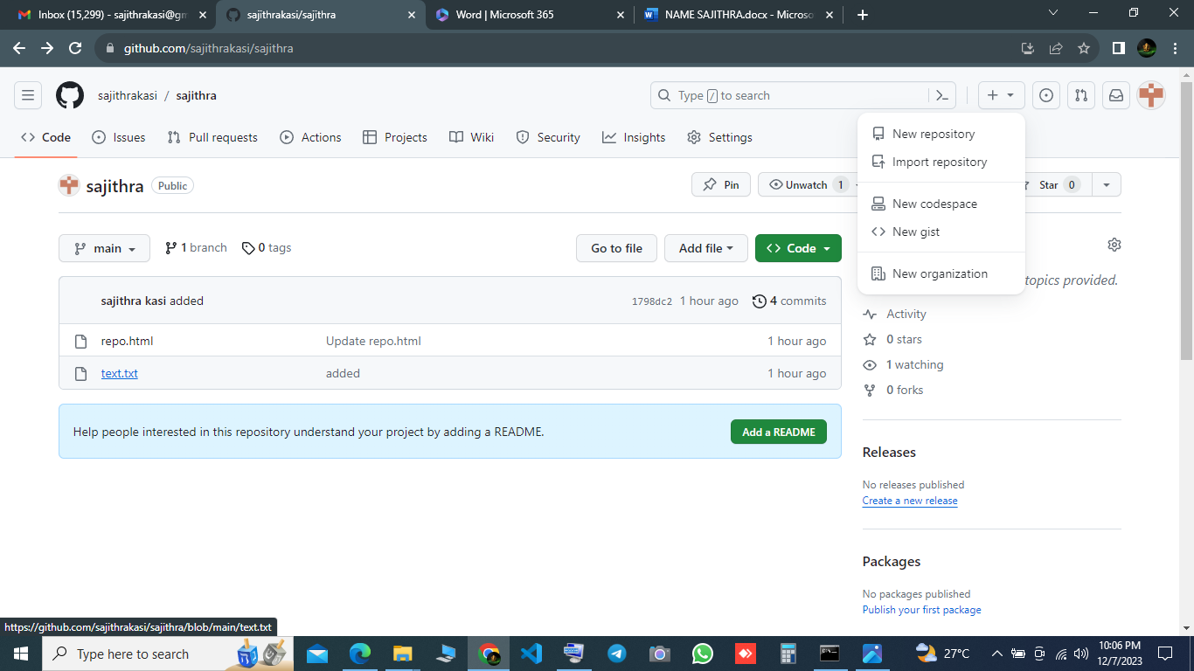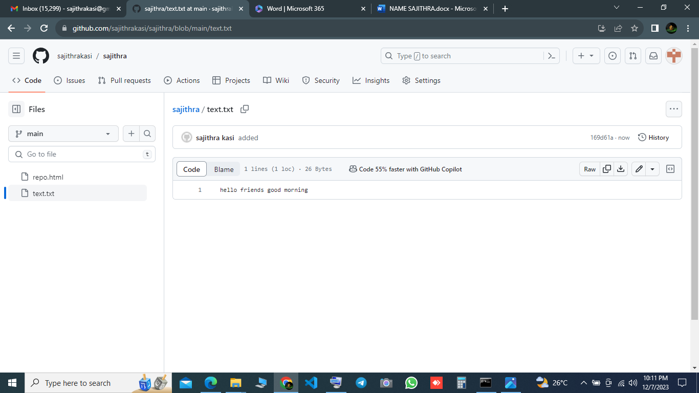

11.PULL COMMAND:



OUTPUT:

